**Experiment 2**

**Date:** 03-08-2021

**Aim:** To design and simulate client to server and peer to peer network.

**Software Used:** Cisco Packet Tracer.

**Theory:**

1. **Client to Server Network:**

* A client and server networking model is a model in which computers such as servers provide the network services to the other computers such as clients to perform a user based tasks. This model is known as client-server networking model.
* The application programs using the client-server model should follow the given below strategies:

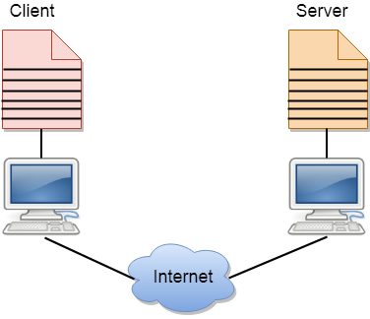

* An application program is known as a client program, running on the local machine that requests for a service from an application program known as a server program, running on the remote machine.
* A client program runs only when it requests for a service from the server while the server program runs all time as it does not know when its service is required.
* A server provides a service for many clients not just for a single client. Therefore, we can say that client-server follows the many-to-one relationship. Many clients can use the service of one server.
* Services are required frequently, and many users have a specific client-server application program. For example, the client-server application program allows the user to access the files, send e-mail, and so on. If the services are more customized, then we should have one generic application program that allows the user to access the services available on the remote computer.

**Client:** A client is a program that runs on the local machine requesting service from the server. A client program is a finite program means that the service started by the user and terminates when the service is completed.

**Server:** A server is a program that runs on the remote machine providing services to the clients. When the client requests for a service, then the server opens the door for the incoming requests, but it never initiates the service. A server program is an infinite program means that when it starts, it runs infinitely unless the problem arises. The server waits for the incoming requests from the clients. When the request arrives at the server, then it responds to the request.

**Advantages of Client to Server Network:**

* **Centralized:** Centralized back-up is possible in client-server networks, i.e., all the data is stored in a server.
* **Security:** These networks are more secure as all the shared resources are centrally administered.
* **Performance:** The use of the dedicated server increases the speed of sharing resources. This increases the performance of the overall system.
* **Scalability:** We can increase the number of clients and servers separately, i.e., the new element can be added, or we can add a new node in a network at any time

**Disadvantages of Client to Server Network:**

* **Traffic Congestion** is a big problem in Client/Server networks. When a large number of clients send requests to the same server may cause the problem of Traffic congestion.
* It does not have a robustness of a network, i.e., when the server is down, then the client requests cannot be met.
* A client/server network is very decisive. Sometimes, regular computer hardware does not serve a certain number of clients. In such situations, specific hardware is required at the server side to complete the work.
* Sometimes the resources exist in the server but may not exist in the client. For example, If the application is web, then we cannot take the printout directly on printers without taking out the print view window on the web.

1. Peer to Peer Network:

* A peer to peer network is a simple network of computers. It first came into existence in the late 1970s. Here each computer acts as a node for file sharing within the formed network. Here each node acts as a server and thus there is no central server to the network. This allows the sharing of a huge amount of data. The tasks are equally divided amongst the nodes. Each node connected in the network shares an equal workload. For the network to stop working, all the nodes need to individually stop working. This is because each node works independently.

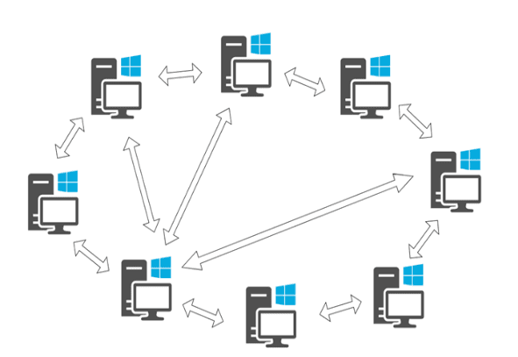

**Types of Peer to Peer Network:**

* **Unstructured P2P Networks:** In this type of P2P network, each device is able to make an equal contribution. This network is easy to build as devices can be connected randomly in the network. But being unstructured, it becomes difficult to find content.
* **Structured P2P Networks:** It is designed using the software which creates a virtual layer in order to put the nodes in a specific structure. These are not easy to set-up but can give easy access to users to the content.
* **Hybrid P2P Networks:** It combines the features of both P2P network and client-server architecture. An example of such a network is to find a node using the central server.

**Features of Peer to Peer Network:**

These networks do not involve a large number of nodes, usually less than 12. All the computers in the network store their own data but this data is accessible by the group. Unlike client-server networks, P2P uses resources and also provides them. This results in additional resources if the number of nodes increases. It requires specialized software. It allows resource sharing among the network. Since the nodes act as servers also, there is a constant threat of attack. Almost all the OS today support P2P networks.

**How to Use Peer to Peer Network Efficiently:**

Firstly secure your network via privacy solutions. Design a strategy that suits the underlying architecture in order to manage applications and underlying data. Keep a check on the cyber security threats which might prevail in the network. Invest in good quality software that can sustain attacks and prevent the network from being exploited. Update your software regularly.

**Advantages of Peer to Peer Network:**

* Network is easy to maintain because each node is independent of each other.
* Since each node acts as a server, therefore the cost of the central server is saved.
* Adding, deleting and repairing nodes in this network is easy.

**Disadvantages of Peer to Peer Network:**

* Because of no central server, data is always vulnerable to get lost because of no backup.
* It becomes difficult to secure the complete network because each node is independent.

**Example of Peer to Peer Network:**

P2P networks can be basically categorized into three levels. The first level is the basic level which uses a USB to create a P2P network between two systems. The second is the intermediate level which involves the usage of copper wires in order to connect more than two systems. The third is the advanced level which uses software to establish protocols in order to manage numerous devices across the internet.

**Observations:**

1. **Client to Server Network:**

1. **Peer to Peer Network:**

**Result:** The design and simulation of Client to Server and Peer to Peer Networking Model has been done successfully.